Volume 6 Issue 3,

July 2010

From the President’s desk.

Amazing. After more than 12 yrs, the NRM finally has all 3 locomotives under one roof. From June 1st to July 14th has been the busiest month and a half in Museum history. Things are still moving along, although it’s slowed down a bit. My thanks to everyone who helped out.

Ken Jones Jr.
President

NRM News

Things are progressing in leaps and bounds out at the NRM shop. Our 3 locomotives are now on site, with 2 of them being moved in the first week of June, and the 3rd in July. I’m still working on getting the boxcars moved, but I’m waiting to see if there is a chance to get something else from CP first. I’d rather move everything in one move, rather than try to co-ordinate 2 or 3 separate moves. Most of the recent happenings are covered elsewhere in the newsletter, so we’ll just keep on moving along.
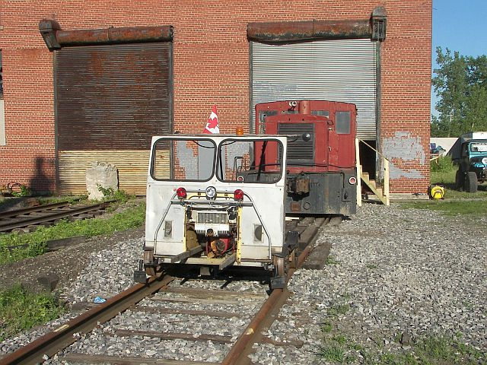
The Fairmont M19 & Plymouth are outside the shop during the first open house of the Niagara Railway Museum.

NRM Equipment

Moving right along, all 3 locomotives are now inside the shop. June 1st saw the long awaited move of HEPC 0-4-0ST #46 to Fort Erie. The move went very smooth, and our mover, Villeneuve’s Steel Wheels out of Sudbury did a great job. It took about 4hrs to load in Orillia, and with the aid of a backhoe, the job was completed safely. It was a 3hr trip to Fort Erie, and upon arrival, once the trailer was positioned, the unload went very quick. Beam excavating provided a front end loader to help get 46 off the trailer and safely onto our rails.

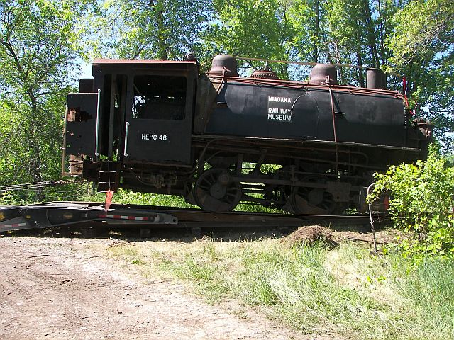
HEPC46 is leaving her longtime home of Uptergrove for Fort Erie on June 1st, 2010.

About 20 people turned out to see the arrival of 46, including members & friends. We also had Cogeco cable 10 come out and do a spot for their show called “The Source”. The 2 minute segment was well done, and many people saw it. The NF Review also did a decent story on the arrival, including a great photo. The Fort Erie Times came out the next day and took a photo and did a story.
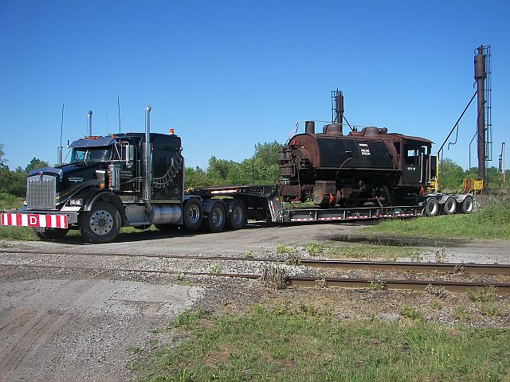
HEPC 46 arrives on the float at the Fort Erie NRM shop on June 1st, 2010.
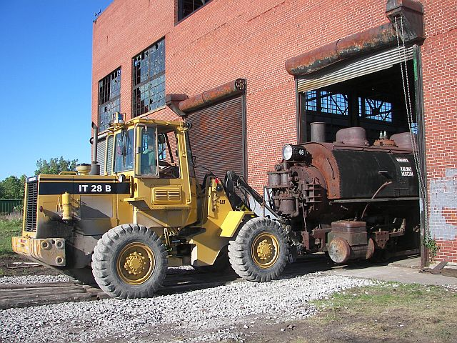
The Cat IT28B provided by Beam Excavating made easy work of taking 46 off the trailer, and shoving it into the shop.

The second locomotive move took place a few days later on June 8th. The move was initially supposed to happen the day after 46 was moved, with the mover being Steel Wheels while they were down here, but some last minute issues with where the Plymouth was stored cancelled that move. Instead, MJ Jones got a crane, and loaded the diesel onto their own float and moved it to Fort Erie. This cost us a bit more as we had to pay extra for the Plymouth move, on top of the steam engine move. However, it was moved safely, and unloaded at the shop, on track 1, in front of 46.
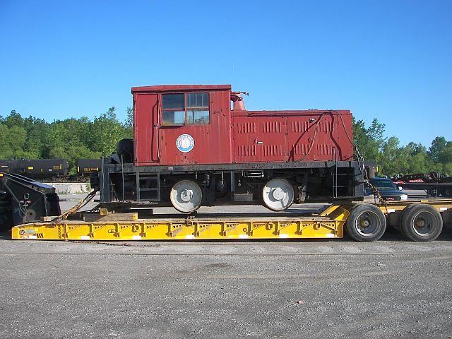
The Plymouth is on the trailer at MJ Jones, ready to be moved to Fort Erie on June 8th, 2010.
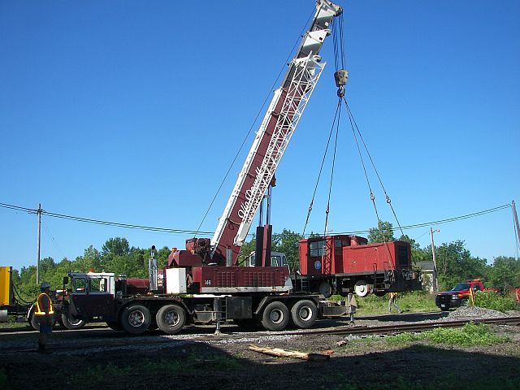
Vic Powell Welding provided the crane to load & unload the Plymouth.
The final move took place July 14/15 and saw our 3rd locomotive, HEPC E-7 (ex-INCo 102) moved from National Railway Equipment in Capreol. The locomotive was owned by the Northern Ontario Railway Museum & Heritage Centre in Capreol, and was acquired when they picked up INCo 101 (a sister to 102) and 116, one of the larger electrics. 102 was pretty much surplus from the start as it had never been updated. Towards the end I think it was used mostly for parts to keep the other electrics in service. 102 is missing a few parts, but most of those can be replaced, as the unit will be a cosmetic restoration only. The arrival of E-7 finished off our very unique display of 3 locomotives from 2 of the best known power projects in Canadian History.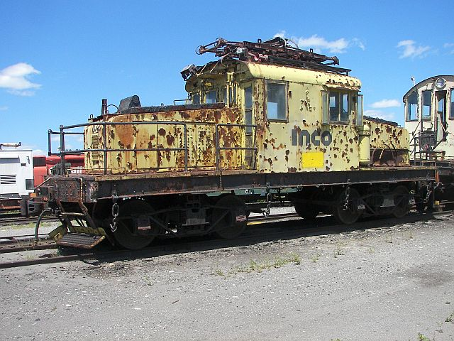
INCo 102 is at NRE in Capreol, prior to being moved into the shop for loading on a float.

It was a bit of a rush trip, as the mover, Steel Wheels again out of Sudbury, sent me a message on the Monday that he wanted to move it Wednesday. So, I headed for Capreol on Tuesday to start prepping the engine for the move. Went to the Museum first to get the engine officially signed over to us, and then over to NRE to see what was going on. Well, it was a bit of a snafu there, as they didn’t know anything about the move taking place, and weren’t ready for it. However, after about an hour, I was able to start working on the traction motors.
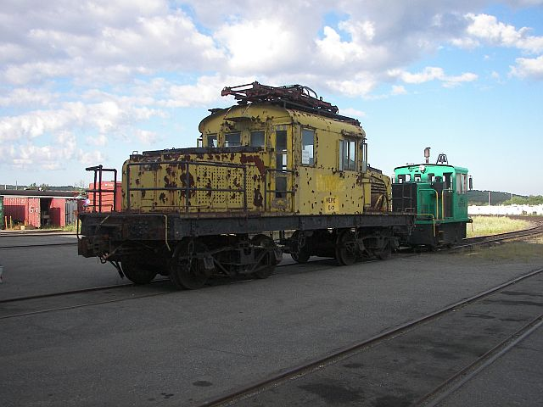
The NRE crew has switched 102 into the shop, and the footboards have already been removed to allow the trucks to be rolled out from underneath.
It wasn’t long after I started working on 102 that the crew came out with their 25ton locomotive to move 102 into the shop to start prepping it for the move the next day. We didn’t use any cranes, other than the 30ton overhead, which was used to just lift one end at a time to roll the trucks out. Equipment jacks were used to lift the body high enough to back the trailer underneath.
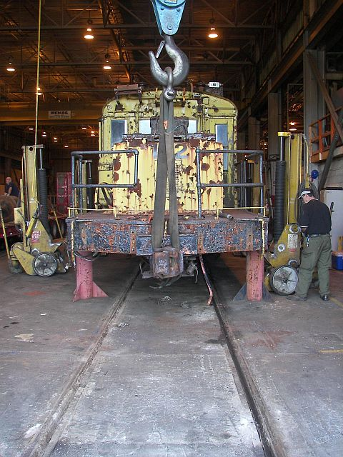
E-7 is lifted by the crane while pillars are put underneath to allow the lifting beam to be slide underneath for the jacks.

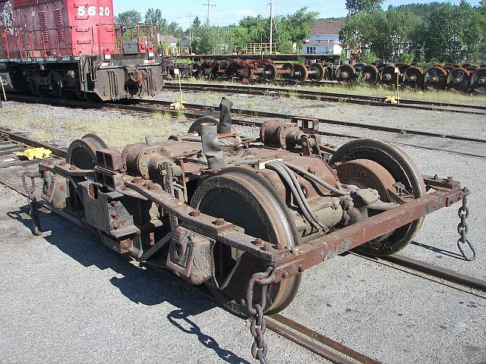
One of the archbar trucks sits outside in the sun after being pulled from under E-7
The entire operation was pretty slick, and the NRE crew was a great help. They did the lift, and helped prepare the loco for loading. However, the crew went home at 3:30, and the truck arrived at 3:30. It was down to Brian, the Plant Manager, Norm, the team leader, myself, and Don Villeneuve, the mover. The engine body was loaded around 5:30 and was to be moved to Fort Erie that night. I was supposed to head down as well, but my truck decided that it didn’t want to start, so I ended up staying yet another night in Capreol. (the starter on the truck was toast!)

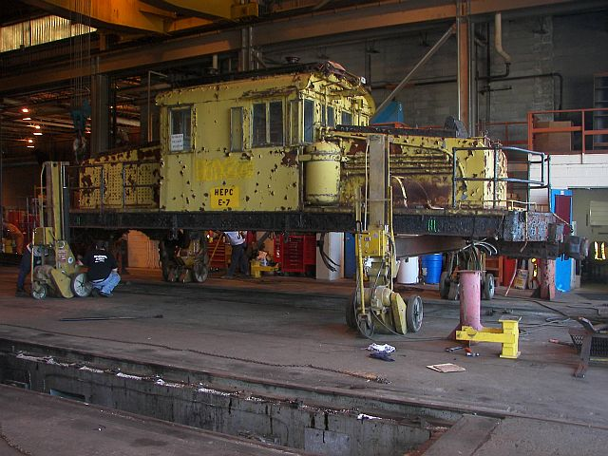
Up on the jacks, waiting for the arrival of the trailer.
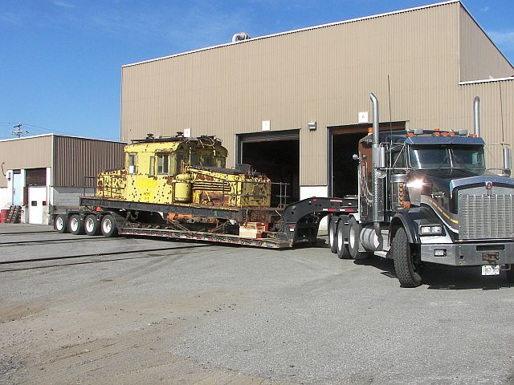
Loaded and ready for the trip to Fort Erie. The body would arrive sometime through the night.

I left my truck at NRE, and got a lift back to the room by the plant manager. I stayed above a small diner in town called the M&R Grill, a diner that has great food. Wednesday is spaghetti night, and I had been saying that morning that I was upset I would be missing it. Well, when I walked back in that night they all had a good laugh and said they knew I’d be back. Anyways, had a good meal the days I was there, and the room was decent as well. Went back to NRE the next morning and loaded my truck onto the float that was taking the trucks from E-7 to the shop. My truck was on the back of the trailer, with the wheels on the deck, and the pantograph on top of the wheels, and the foot boards on the tongue.
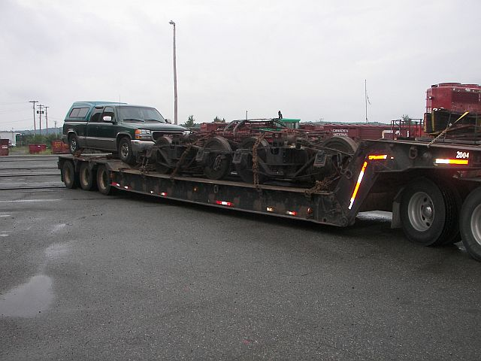
My truck, with the trucks, on the truck!!
The trip to Niagara was a good one, with our truck arriving about 530pm. However, the crane didn’t arrive until almost 8pm, so that meant unloading E-7 in the dark. As soon as the 60ton Grove crane from PRW arrived, we unloaded the trucks and got them on track 2 in position. My truck was removed from the trailer and towed to the garage in Niagara Falls. The body and crane were moved to the other side of track 2 (in the dark) and after some figuring on how to lift, the cables were slung under the body, and the lift began. It was a very slow lift, and the body was spun 180degrees to match up properly with the trucks. Shortly after 11pm the body was reunited with the trucks. Once again, Beam Excavating helped us out by providing a brand new fresh off the truck delivery of a Cat 420E backhoe to help move E-7 into the shop. They also unloaded the pantograph and steps for us while we were waiting. The backhoe moved E-7 into the shop easily, and it now sits over the pit.

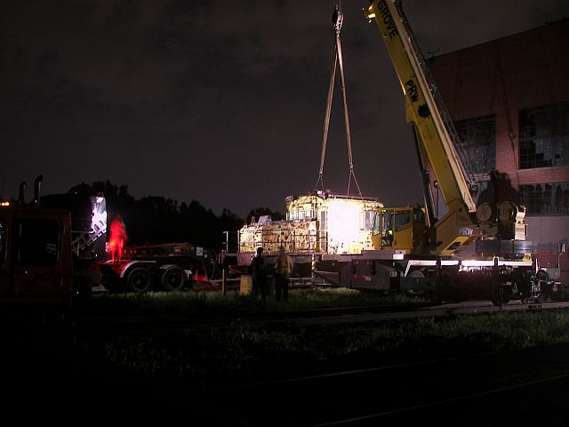
E-7 is off the trailer deck, ready to swing around and be reunited with its trucks.

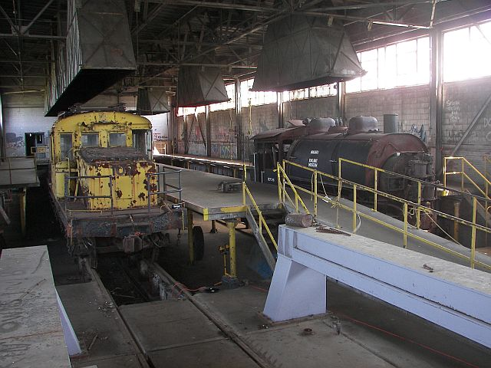
Together again for the first time since 1922, HEPC E-7 & 46 share shop space at the Museum.
Equipment restoration will continue, and with the arrival of HEPC E-7 (ex-INCo 102) there is lots to do. Paint scraping can be done on both the Plymouth and E-7. I cleaned out the debris, resistor grids, and dirt off the floor, and we are now able to walk around the cab without killing ourselves. Mark Lonsbury & I also spent some time the one Saturday boarding up the windows on E-7, just in case someone got back in and tried to smash out more windows.
Unfortunately, numerous vandalism attacks have caused almost $5000 in damages to windows and other equipment. The good news is we have the names of those that caused this vandalism and will be dealing with the police on that. In total, 18 windows were smashed, and the M19 was rammed into the A4d gangcar, causing extensive damage to the back end supports. The windows and front headlight were also smashed on the M19. That car is now on the trailer at the house awaiting repairs. The A4 had all but 1 window smashed, and they weren’t happy the first time, so they came back a second time and smashed them out even further. The Plymouth was also hit hard with many windows being smashed on that as well.
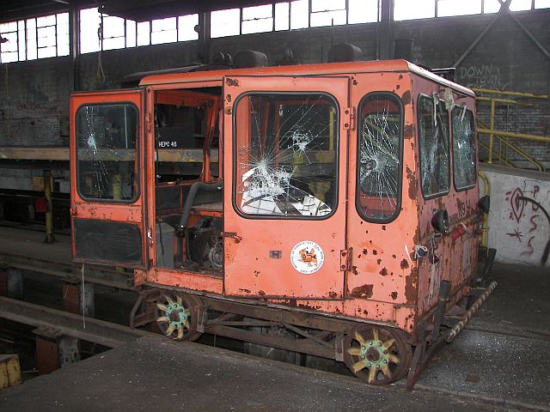
The NRM’s A4d gangcar shows the extensive damage caused by the vandals.
However, despite the damage done by these criminals, we did not let them ruin the open house. We will NOT let them win, and they will be caught. I have not come this far working on the Museum to let a bunch of teenage criminals destroy my work. Yes, it is costly to replace the windows and such, but we will keep going. Other damage done included the destruction of my sickle bar brush cutter, which was run off the work platform into the pit, bending the cutting bar, and driving the fuel tank into the carb. They also ruined the recoil unit on my ride on tractor, which we hoped to use (with some sort of trailer) to haul debris out of the downstairs rooms. This one can be rebuilt, but the brush cutter is likely beyond repair. It is upsetting that these teenagers feel that they need to destroy something that will improve the area. I have been told the reason they are doing this is because they think it is their right to be in that building, as for many years they could come & go as they pleased. However, we will be putting a stop to this. We did have another break in, but the “kids” were caught by police and delivered home to their parents, and no damage was done. However, they were caught up on top of the crane, and all were under 12. If they had slipped, they would have been either seriously injured, or killed.
I send my thanks out to the NRM members who helped prepare the shop in short notice for the arrival of E-7. I also thank NRE-ALCO locomotive of Canada for their professionalism and courtesy in loading E-7, Don Villeneuve of Villeneuve’s Steel Wheels and his other driver John, for moving all the parts to the shop. Peter from PRW crane provided the crane at a reasonable price, and did exactly what we needed. Beam Excavating for once again helping out, by sending the backhoe, and 2 guys, Jeff & Paul who were a big help in unloading and moving E-7 into the shop. The NORMHC in Capreol for holding off scraping 102 and allowing us to acquire the locomotive for our own collection.

Donations & Acquisitions

There have been a few financial donations over the past month or so, the Canadian National Pensioners Association of Niagara made a donation, as did Dave Speigelman. Dave is also donating a few items to us including a jack, spike maul, and a tamping hammer. We also had some slides of the TH&B donated to the NRM, and I hope to get some of those scanned in when I’m back in Niagara. We have also picked up more NS&T and CNR slides off ebay, including 2 rare ones at Port Dalhousie.
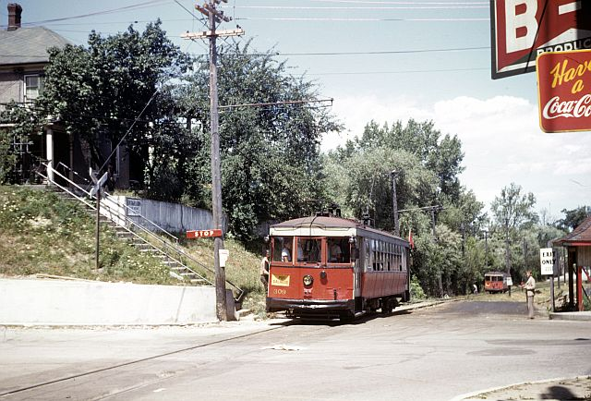
NS&T 309 is at the main intersection in Port Dalhousie on July 24, 1948.

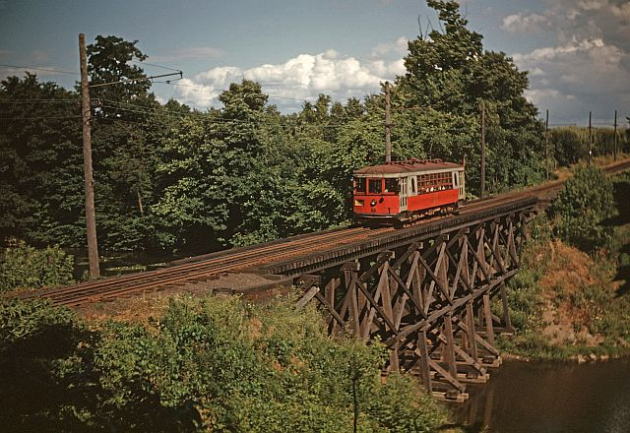
Likely taken shortly after the previous photo, 309 is the way out of Port Dalhousie on July 24, 1948.

Displays and other events

As previously mentioned, the first open house at the shop on July 2-4 was a great success. About 120 people came out, and we raised some funds as well. While the majority of the shop was closed off to visitors, people still liked what we were doing. Our next open house will be on September 11/12. We’ll now be able to display 3 of our locomotives, and offer rides on the M19. There is also a chance we may be able to get our boxcars moved to the site. There is still quite a bit of work to do before that time, so I hope we’ll get more members out to help. So far we’ve been lucky and have had steady work sessions, however, Ray, Steve & myself have all recently become employed again, so our crew has been cut down drastically.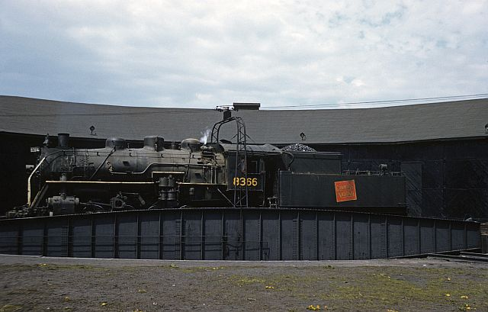
CNR P-5-f 8366 rides the NF turntable on May 10, 1958. This is the 3rd shot of 8366 we have, which adds to having the actual number plate from the engine.

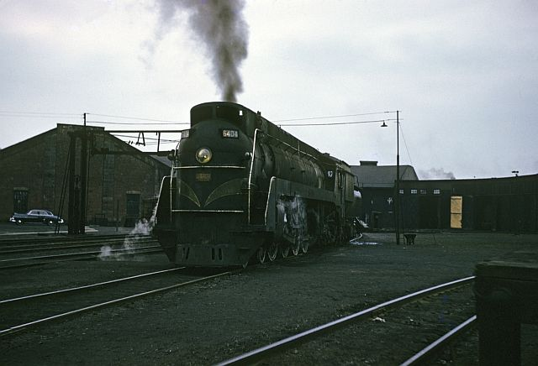
CN 4-8-4 #6404 is on the turntable lead after being serviced at Niagara Falls on April 27, 1958.

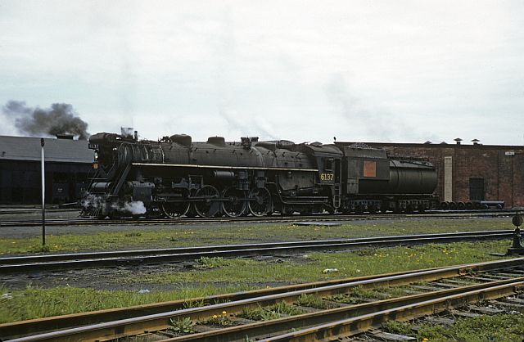
Another engine with 2 views, is this recent acquisition of CNR
4-8-4 #6137 at Niagara Falls on May 10, 1958.

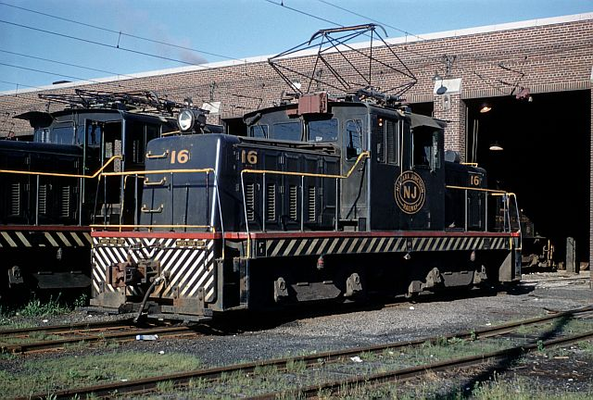
Niagara Junction electric #16 sits in front of the NJ shops in Niagara Falls, NY on July 19, 1958.

Upcoming Shows/Events

Wednesdays & Saturdays – Work days at the shop. must wear safety footwear, bring a hard hat and safety glasses. Prepare for any work/weather.

September 11/12, 2010 – Open house at the Niagara Railway Museum shop in Fort Erie. 9am to 4pm each day.

October 31st, 2010 – 4th Annual Niagara Falls “Fall” Model Railway Show. Optimist Park Hall, 10am-3:30pm

The next issue will be out in
September 2010.

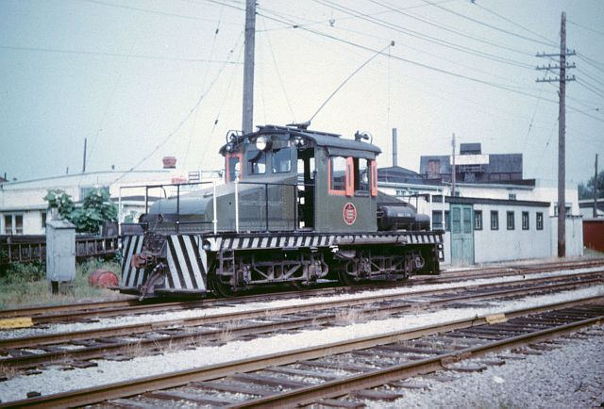
NS&T electric #14 is at St. Catharines in 1959.
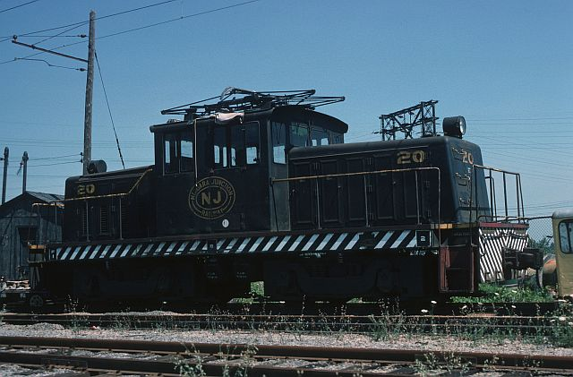
Niagara Junction 30 is at the NJ shop in Niagara Falls NY in July 1977.

